**Implementation of a Scalable Serverless Website Visitor Counter.**

**AWS SERVICES USED:**

1. AWS Lambda

2. API Gateway

3. DynamoDB

4. S3 (Simple Storage Service).

**AWS ARCHITECTURAL DIAGRAM:**

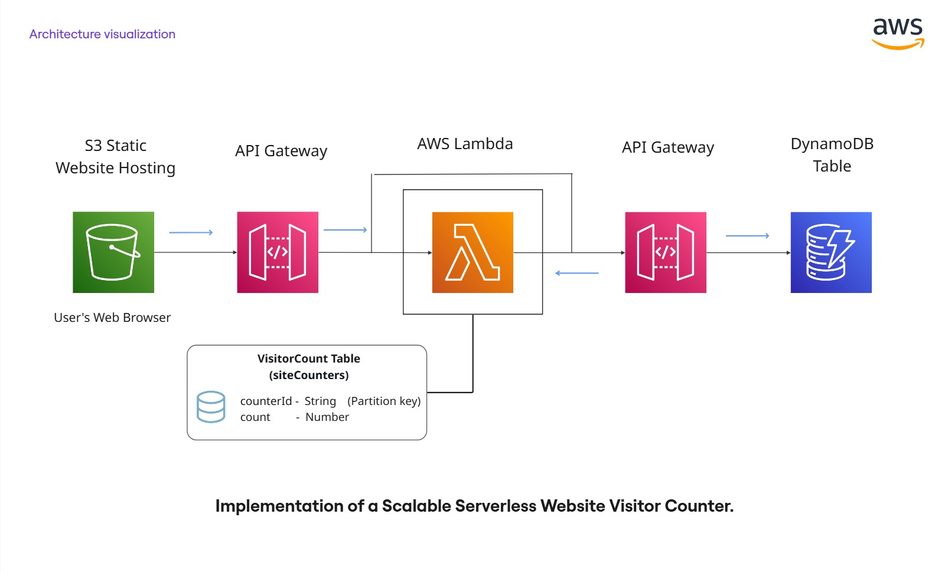

- This diagram shows a **serverless website visitor counter architecture** using AWS services.

- A static site on S3 calls API Gateway, which triggers a Lambda function that reads and updates visitor counts stored in DynamoDB.

**OVERVIEW (ONE-LINE)**

User visits site → browser `fetch()` hits API Gateway → API Gateway calls Lambda → Lambda atomically `ADD`'s 1 to a DynamoDB item and returns the new count → browser displays it.

🡪 Here, we will see step by step process of how this architecture works in detail.

**AWS IAM:**

- IAM - Identity and Access Management is a service that lets you securely manage access to AWS resources.

- It enables you to control who can do what in your AWS account through users, roles, and policies.

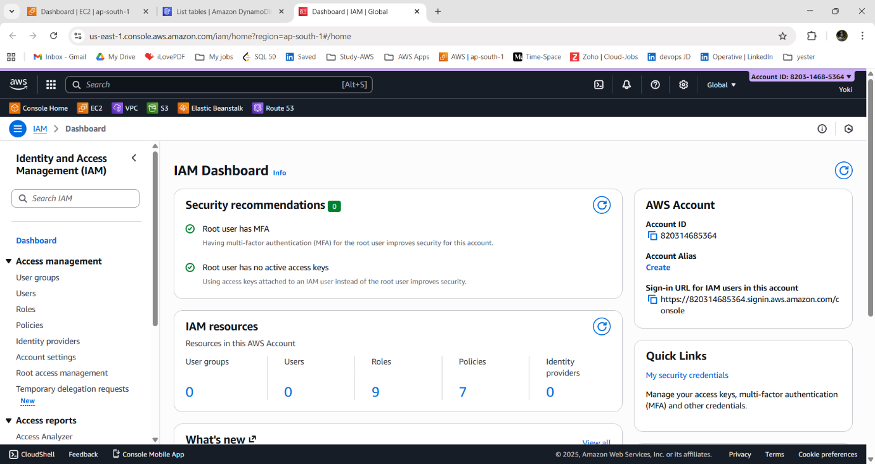

**Step:1 - Create IAM role for Lambda:**

- Minimal policy — allows Lambda to update the table and write logs.

- IAM policy JSON (attach to role).

1. Choose trusted entity

Select: **AWS service**

Choose: **Lambda and** Click **Next**

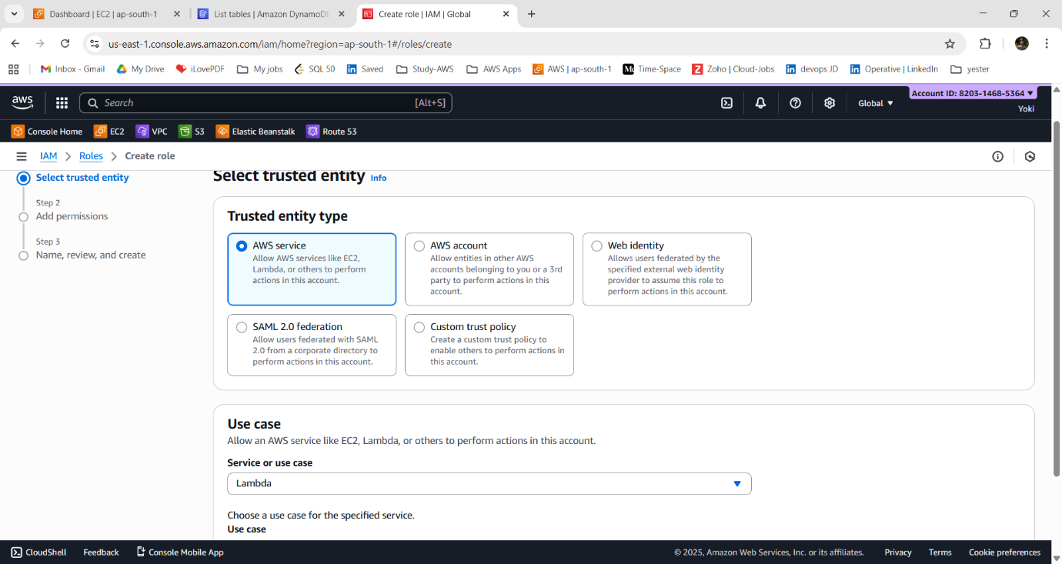

2. Attach permissions: - Search for these policies

**AmazonDynamoDBFullAccess** - Lambda can update the counter

**CloudWatchLogsFullAccess** - Lambda can write logs

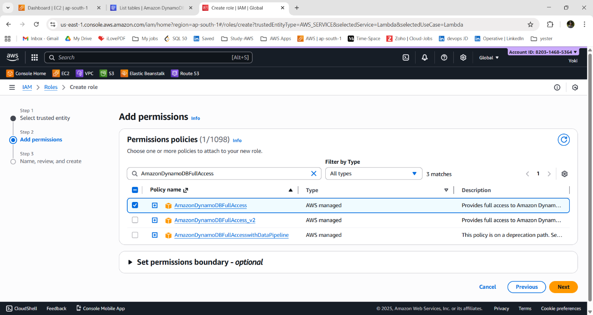

~ Click **Next**.

3. Name the role:

Role name: **lambda-dynamodb-counter-role**

- Click **“Create Role”.**

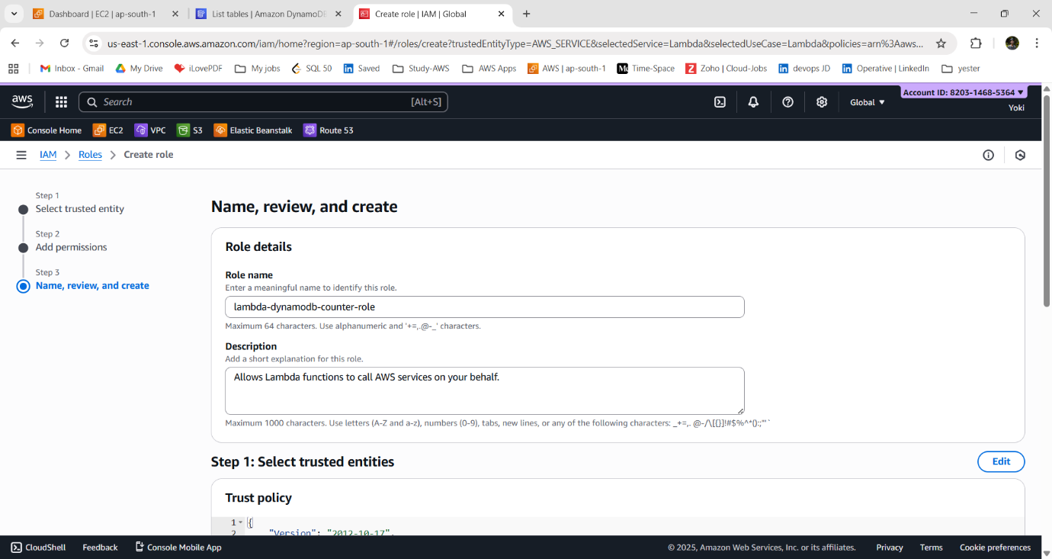

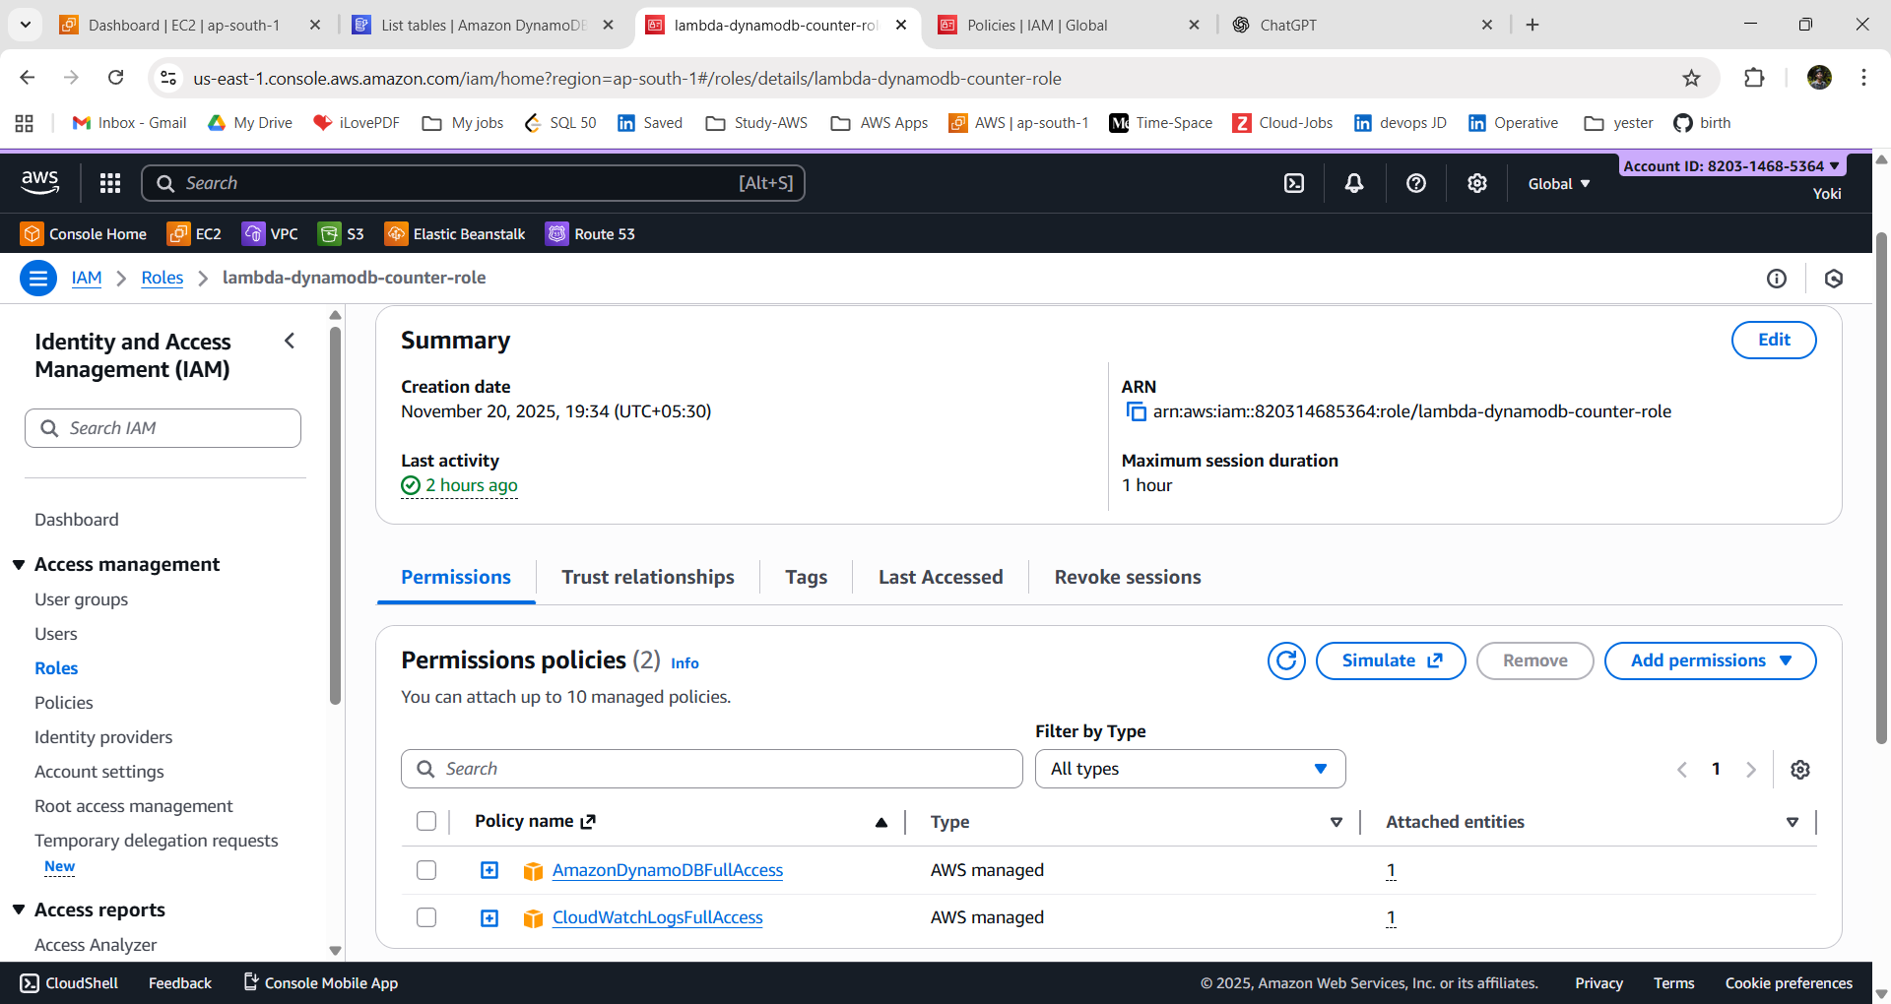

**AWS Lambda:**

- AWS Lambda is a serverless compute service that runs your code automatically in response to events without provisioning or managing servers.

- It lets you execute code on-demand and scale automatically, with billing based only on compute time used.

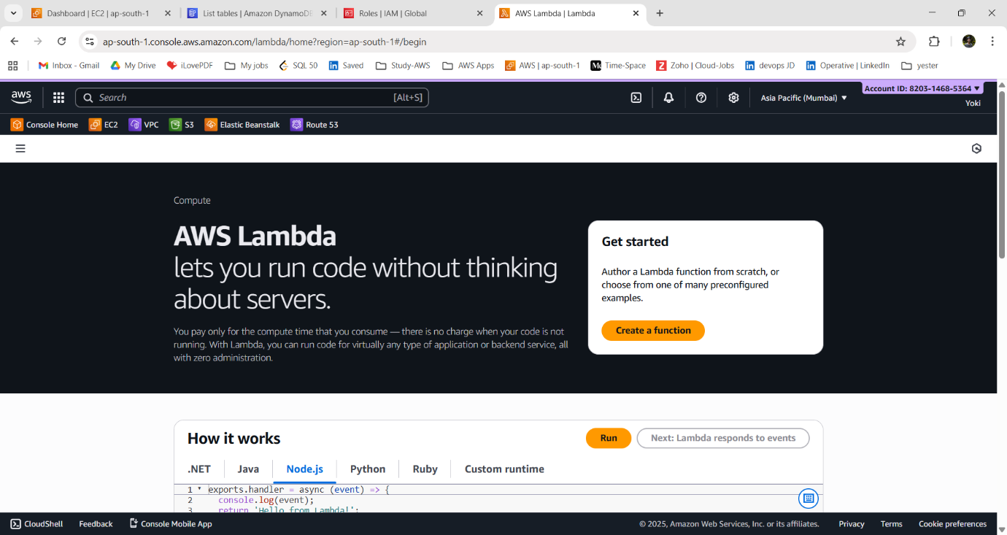

**Step:2 - Create Lambda Function:**

1. Create function.

Choose: **Author from scratch**

Function name: **VisitorCounterFunction**

Runtime: **Node.js 22.x**

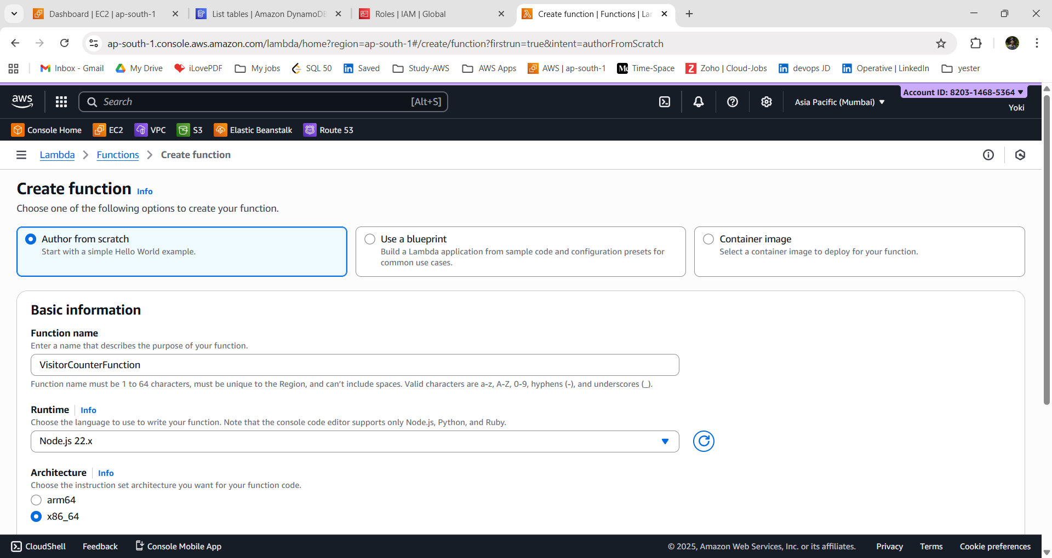

2. Change “**Execution Role**” section: Select Use an existing role

- Choose the role you created: **lambda-dynamodb-counter-role**

- Click **Create Function.**

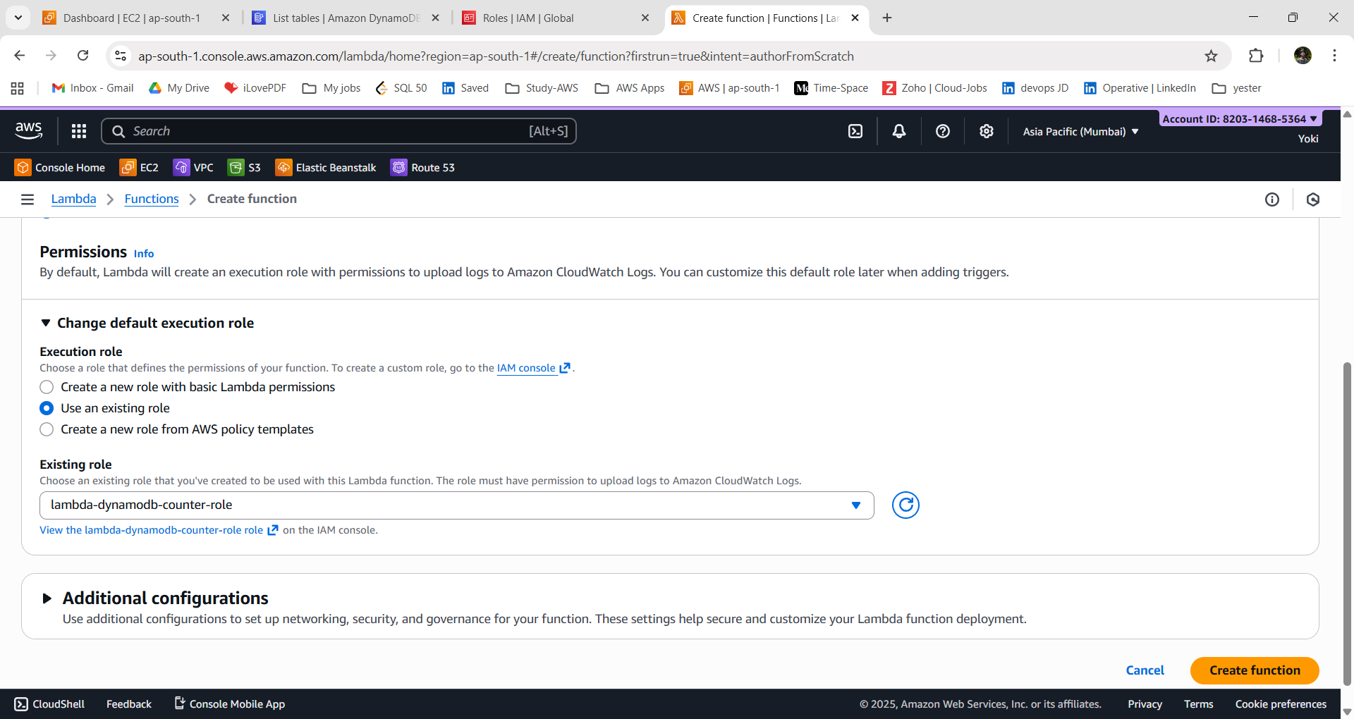

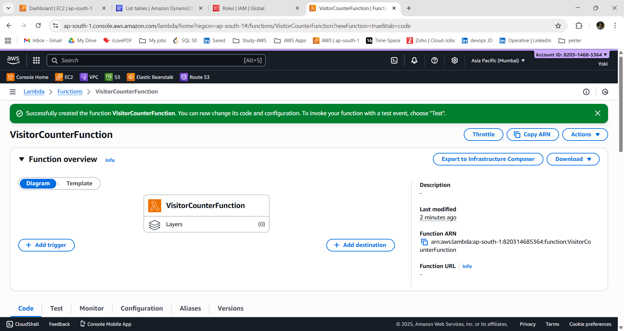

**Step:3 - Add Lambda Code:**

1. Go to 🡪 **“Code” section**

2. You will see a file called: **index.mjs (or index.js)**

3. Delete the default code.

4. Paste the below code.

```

import { DynamoDBClient, UpdateItemCommand } from "@aws-sdk/client-dynamodb";

const ddb = new DynamoDBClient({});

export const handler = async () => {

  // DynamoDB table and counter ID

  const TableName = "siteCounters";

  const CounterId = "visitors";

  // Atomic increment

  const params = {

    TableName,

    Key: { counterId: { S: CounterId } },

    UpdateExpression: "ADD #count :inc",

    ExpressionAttributeNames: { "#count": "count" },

    ExpressionAttributeValues: { ":inc": { N: "1" } },

    ReturnValues: "UPDATED_NEW",   };

  const result = await ddb.send(new UpdateItemCommand(params));

  const totalVisitors = result.Attributes.count.N;

  return {

    statusCode: 200,

    headers: {       "Access-Control-Allow-Origin": "*",     },

    body: JSON.stringify({ value: totalVisitors }),

  };

};

```

5. Click **“Deploy”.**

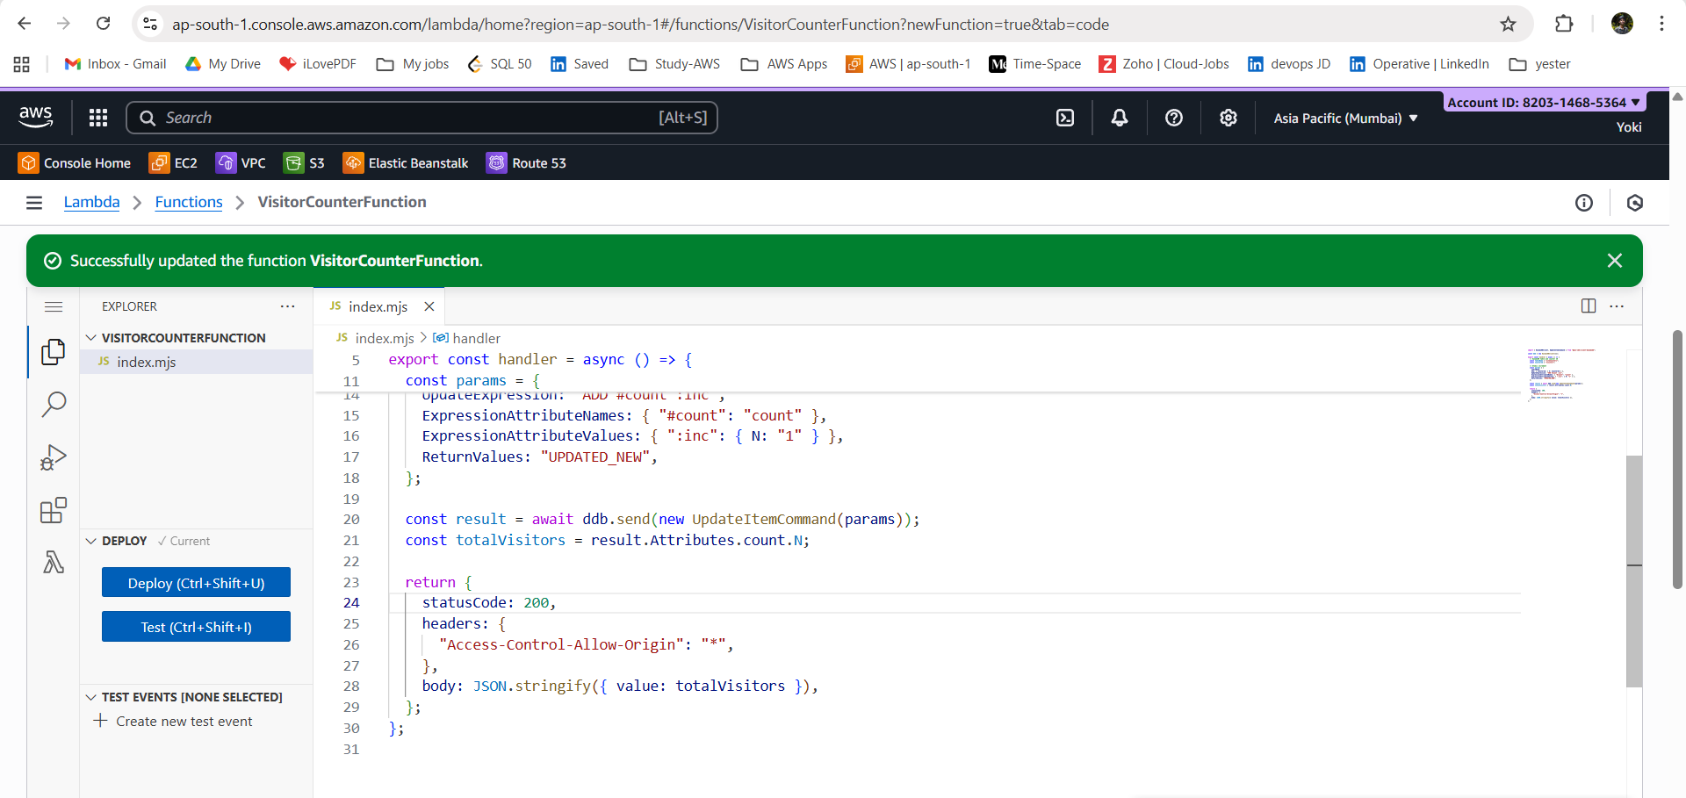

**AMAZON DynamoDB:**

- Amazon DynamoDB is a fully managed NoSQL database service from AWS that provides fast, predictable performance at any scale. It offers key-value and document data storage with built-in availability, security, and automatic scaling.

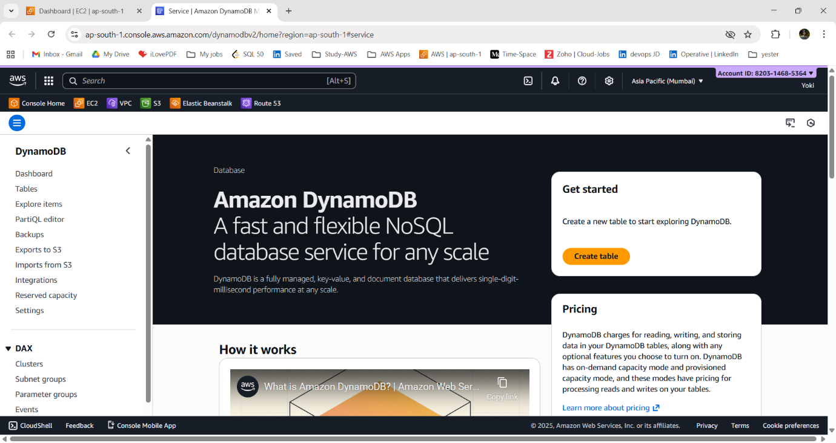

**Step:4 - Create DynamoDB table:**

1. Go to DynamoDB → Create table.

**Table name:** siteCounters

**Partition key:** counterId (String)

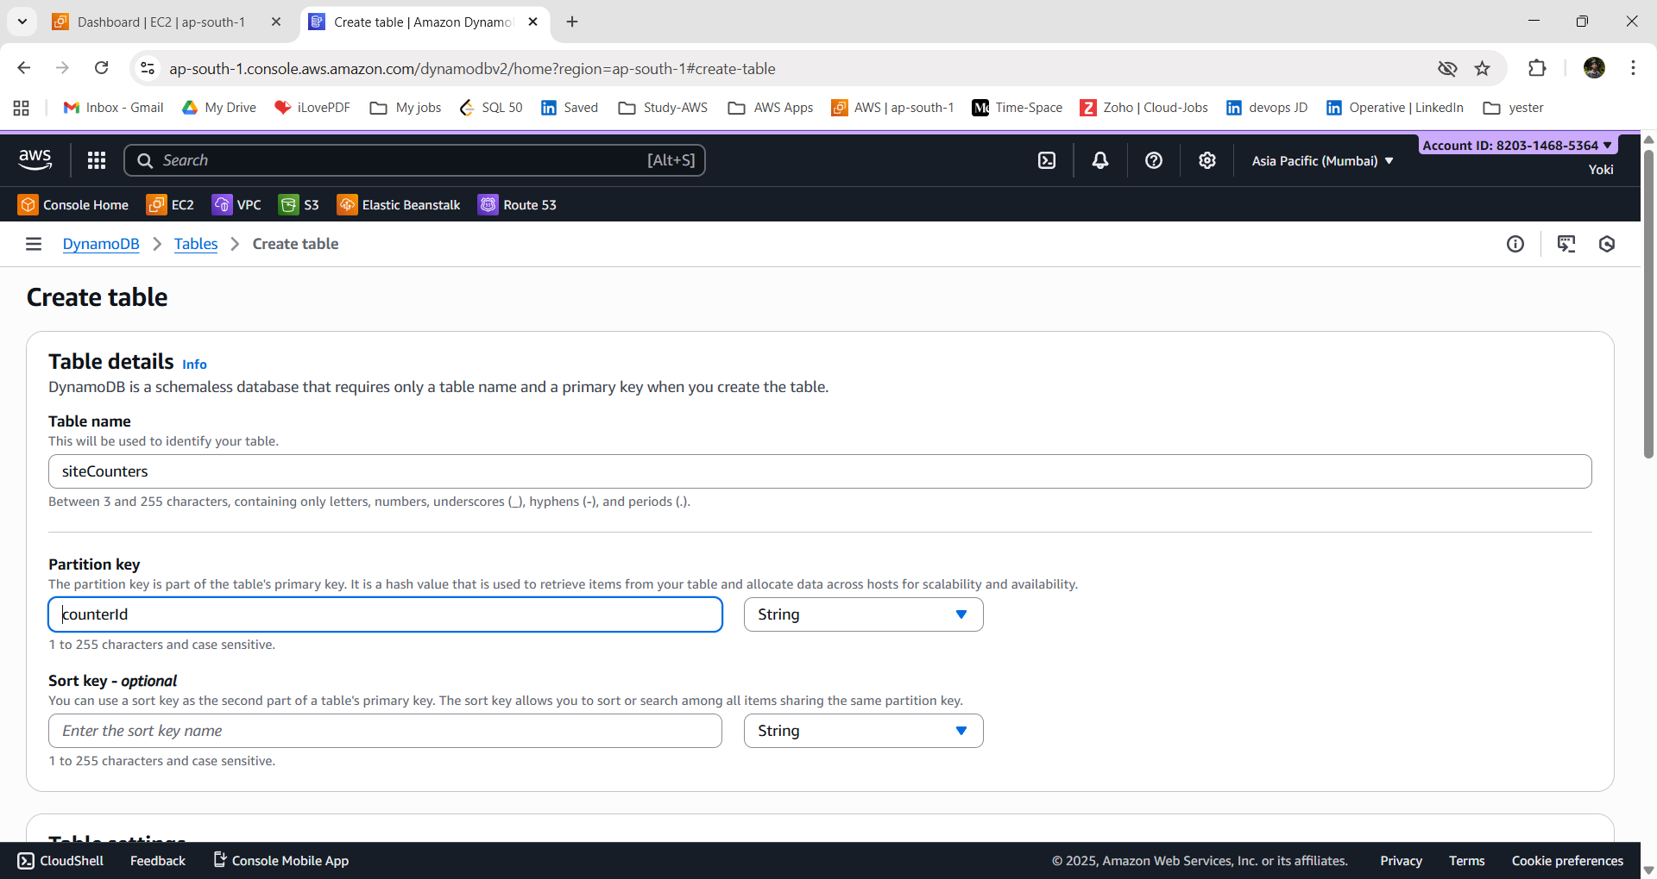

2. Billing mode: Capacity mode = **On-demand**

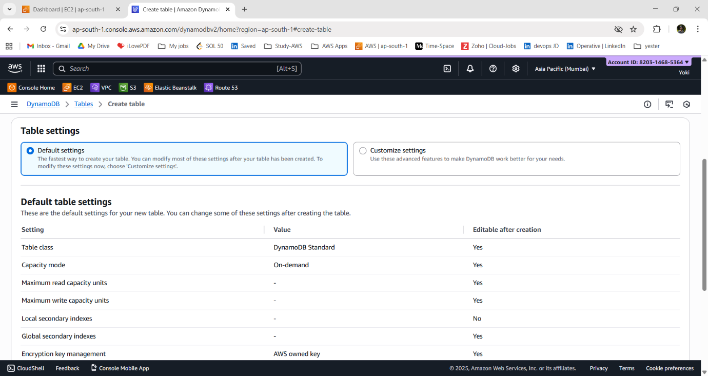

3. click **“Create table”.**

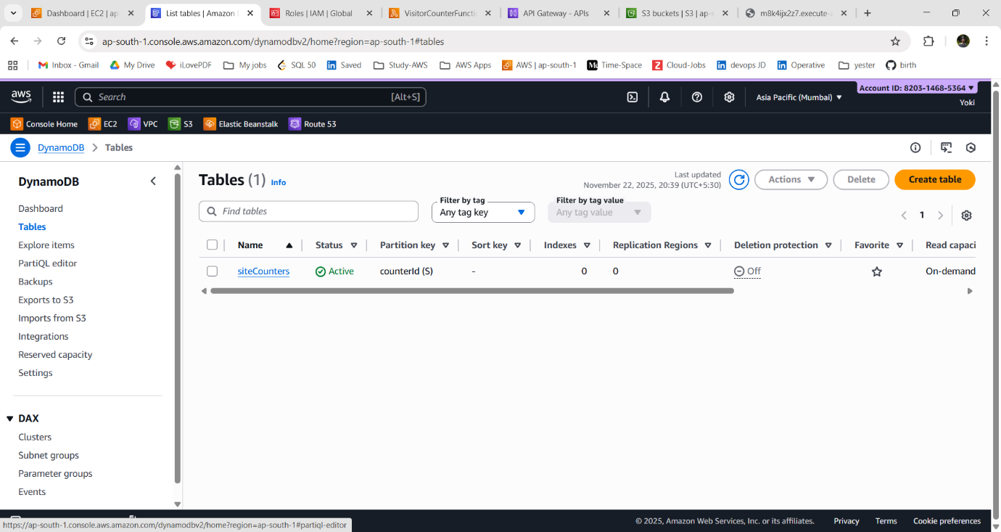

4. Add the first item.

5. Go to: Items → Create item

**counterId** (Partition key) : visitors - string

**count** : 0 - number

6. Click **“Create item”.**

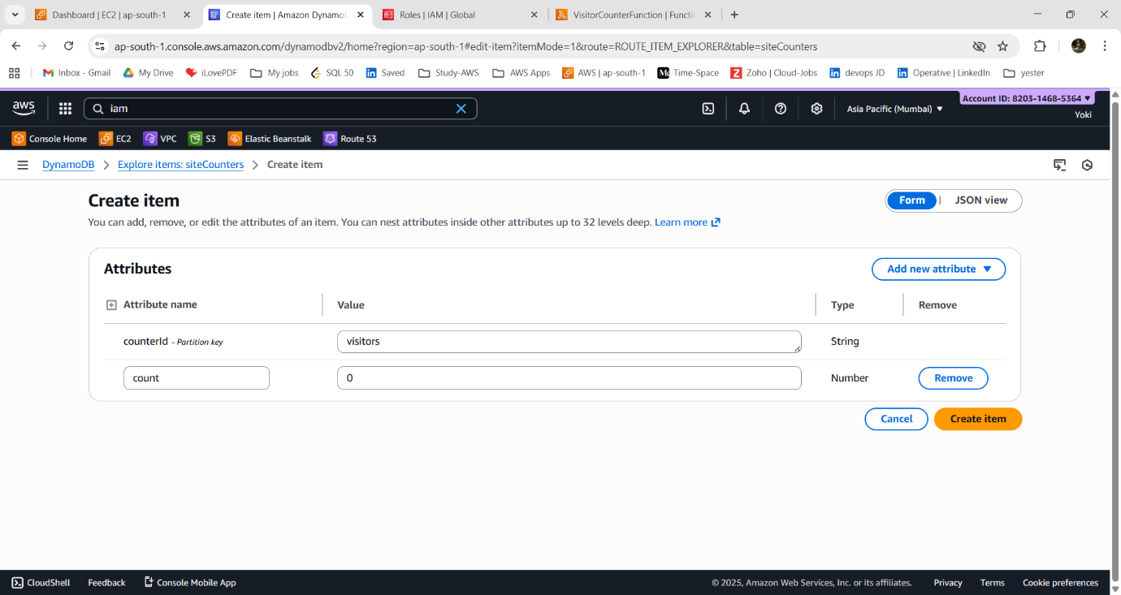

**API GATEWAY:**

- It is a fully managed service that lets you create, publish, secure, and monitor APIs at any scale.  
- It acts as a front door for applications to access backend services like Lambda, EC2, or microservices.

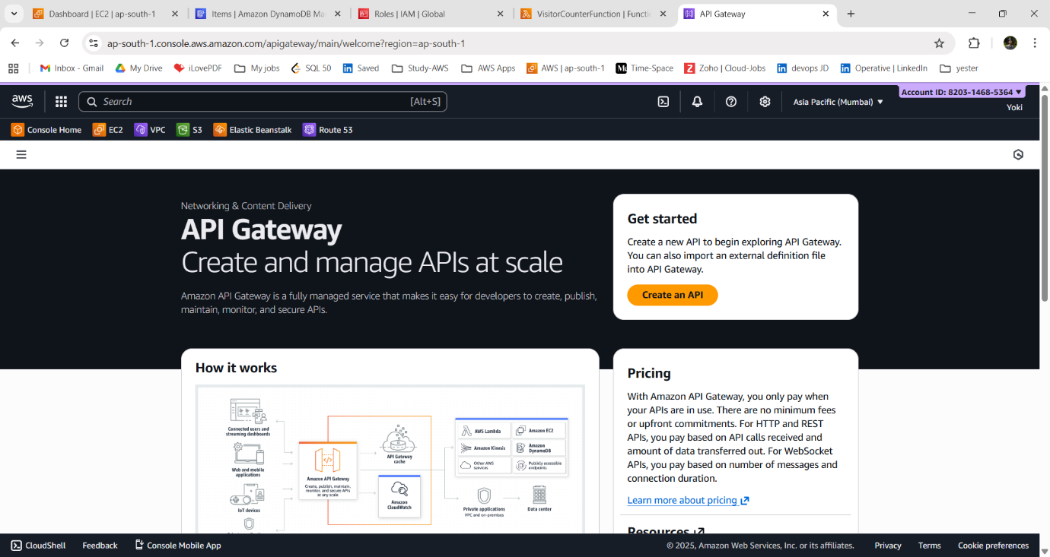

**Step:5- Create API Gateway:**

1. Go to API Gateway 🡪 Create API.

2. enter API details:

API name: **VisitorCounterAPI**

IP Address: IPv4

3. Integrations 🡪 Choose: **Lambda**

AWS Region: **ap-south-1**

Lambda Function: **arn:aws:lambda-functionVisitorCounter**

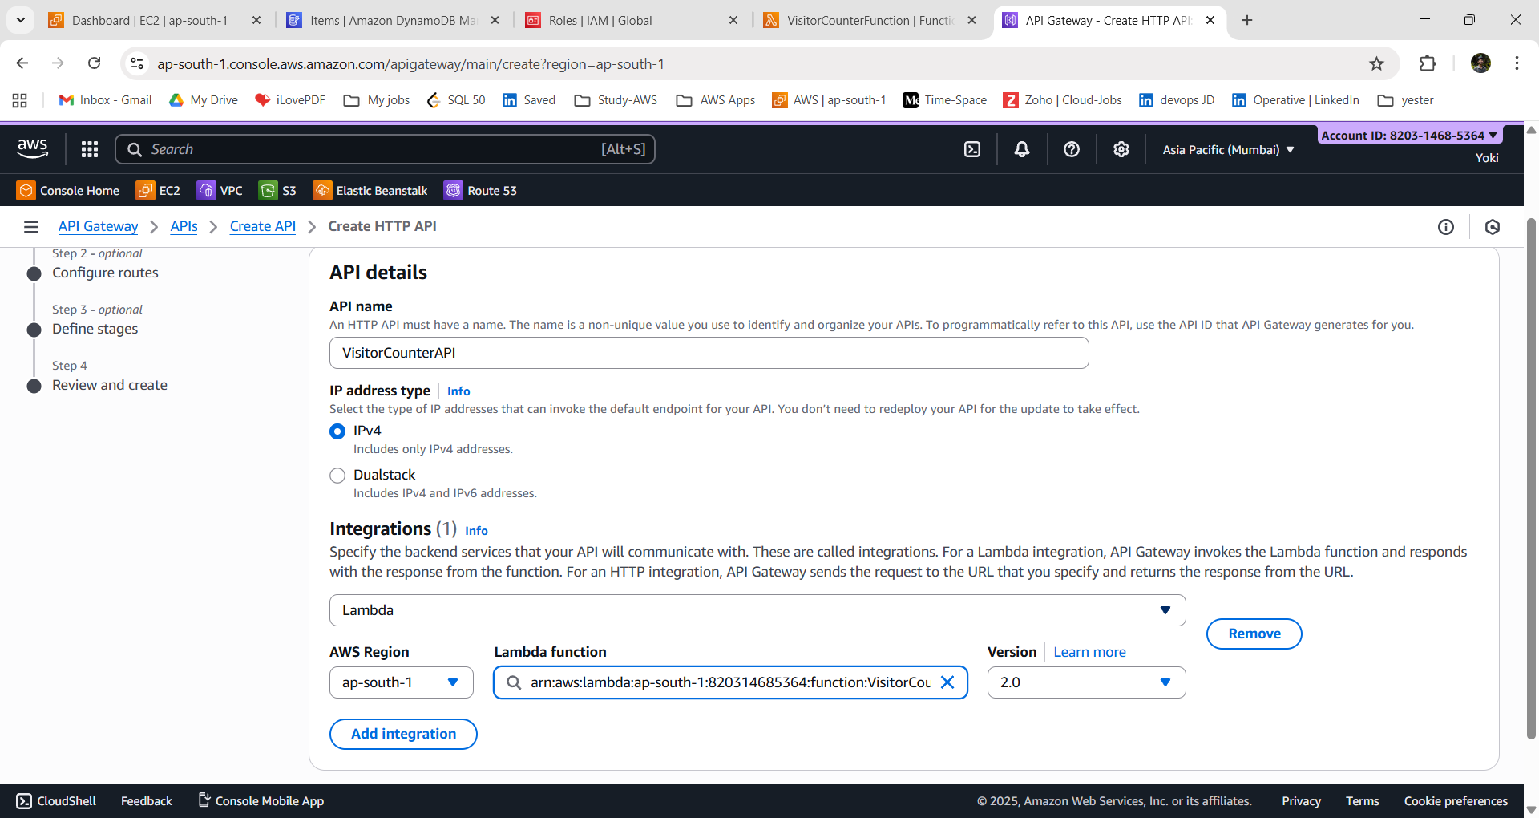

5. Configure routes:

Method: **GET** Path

Resource path: **/count**

Integration Target: **VisitorCounterFunction.**

6. Define stages = default

7. Review and create.

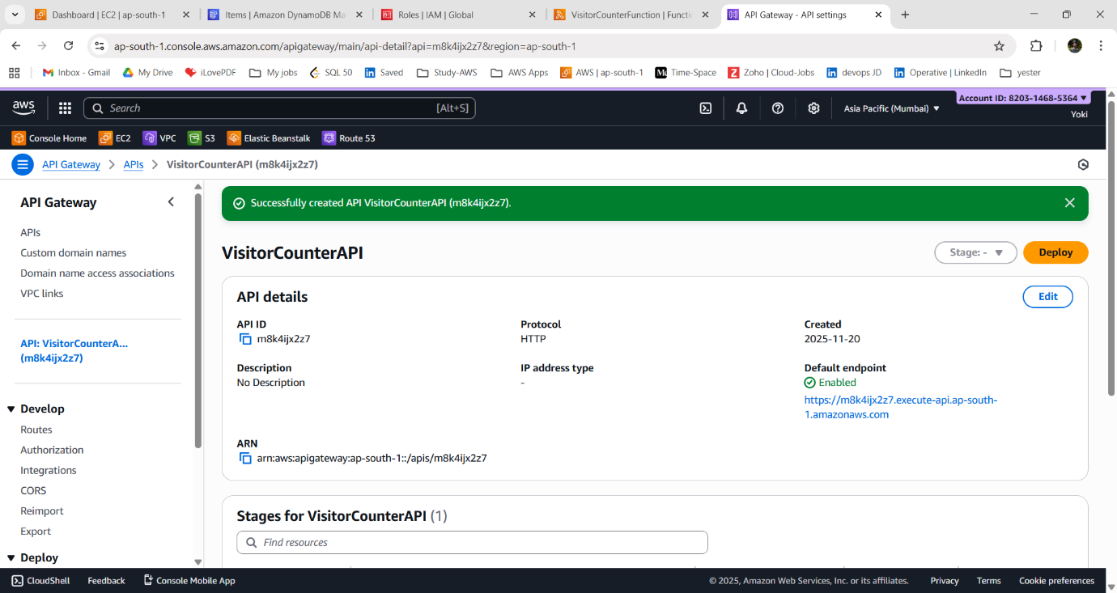

**Step:6- Copy Endpoint:**

1. In your API → go to Stages → Select default.

2. Copy the Invoke URL.

e.g., https://abcdedf.execute-api.ap-south -1.amazonaws.com .

3. Open your browser/Postman and test:

4. And add the route path **“/count”.**

[**https://m8k4ijx2z7.execute-api.ap-south-1.amazonaws.com/count**](https://m8k4ijx2z7.execute-api.ap-south-1.amazonaws.com/count)

→ You should see something like:

{"value":"2"}

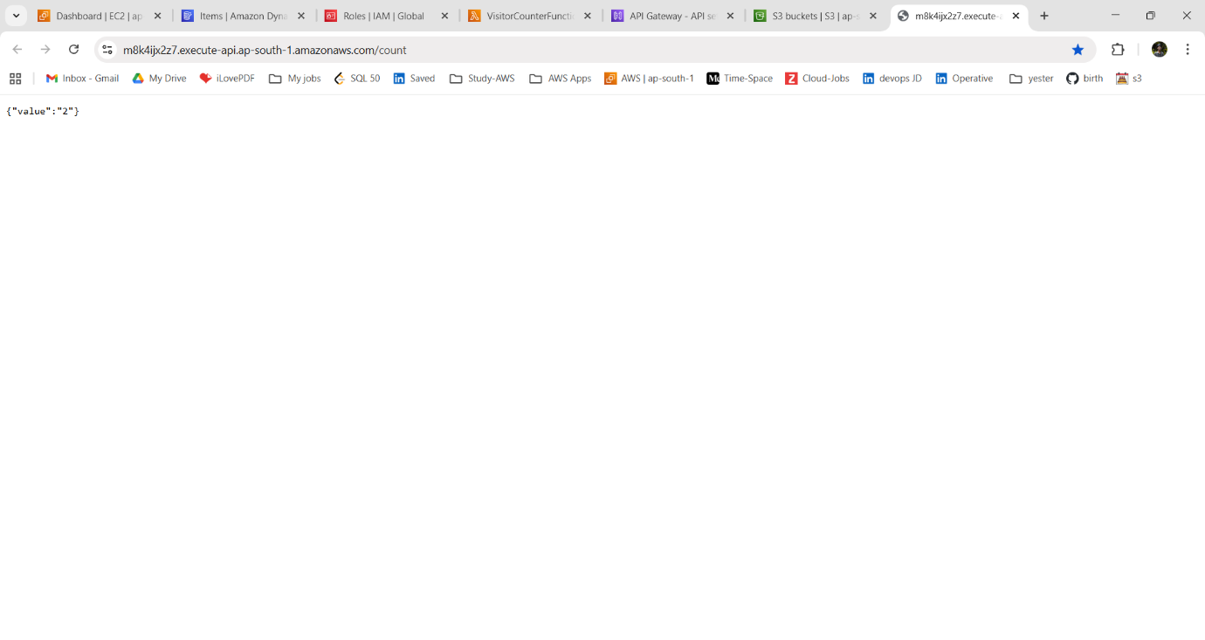

**OUTCOME:**

Here’s an outcome description of the project *before hosting the website on S3*, based on the steps listed:

~ The project successfully set up a scalable backend system by creating an IAM role, building a Lambda function, and adding the necessary code to process visitor counts.

~ A database table was created to store visit data, and APIs were configured to allow secure access to the counter.

~ The API endpoint was generated and ready to be integrated into a frontend or S3-hosted static website.

**STATIC WEBSITE HOSTING ON AMAZON S3:**

**~** project-name: **s3-dynamic-visitor-counter**

-This document describes how to host a static website using Amazon S3’s built-in static hosting feature.

- This approach is suitable for simple static sites that do not require HTTPS, backend logic, authentication, or private hosting.

**S3 STATIC HOSTING:**

- S3 static hosting in AWS is a feature that lets you host static websites (HTML, CSS, JavaScript, images) directly from an Amazon S3 bucket without needing a web server.

- It serves your site via HTTP/HTTPS with high availability and low cost.

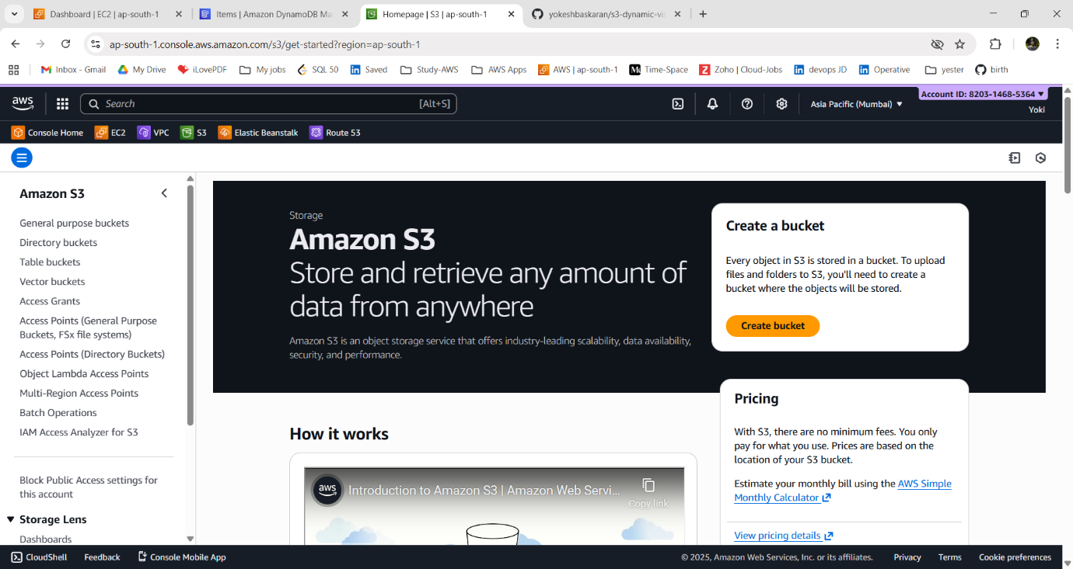

Here, we will see how to host a static website using Amazon S3’s built-in static hosting feature. This approach is suitable for simple static sites that do not require HTTPS, backend logic, authentication, or private hosting.

~ Go 🡪 AWS Management Console and Open the S3 service.

**1. Create an S3 Bucket:**

i) Choose **“Create bucket”.**

ii) Enter the bucket name (must be globally unique).

Bucket-name: **s3-dynamic-visitor-counter**

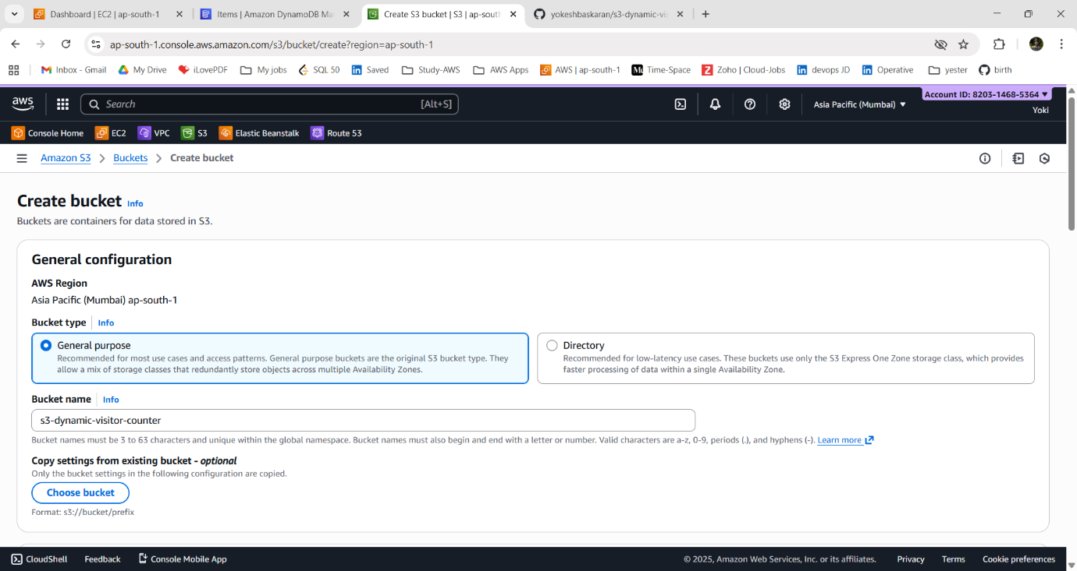

iii) Select an AWS Region - **ap-south-1**

iv) **Create the bucket.**

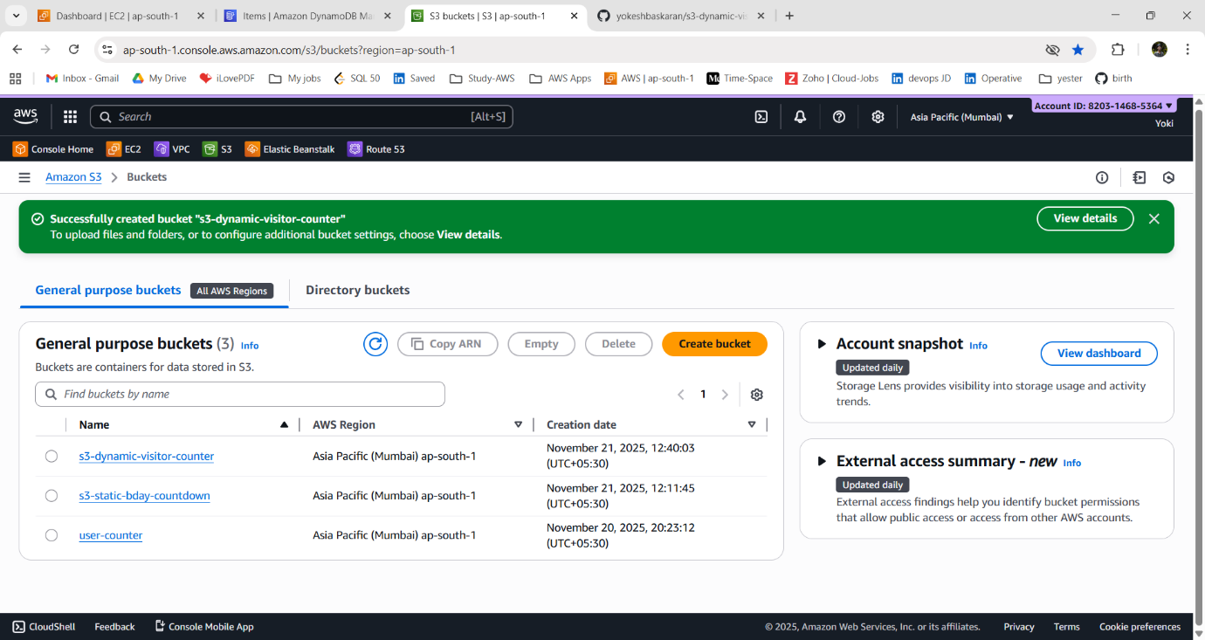

**2. Upload Your Website Files:**

i) Open the s3-dynamic-visitor-counter bucket.

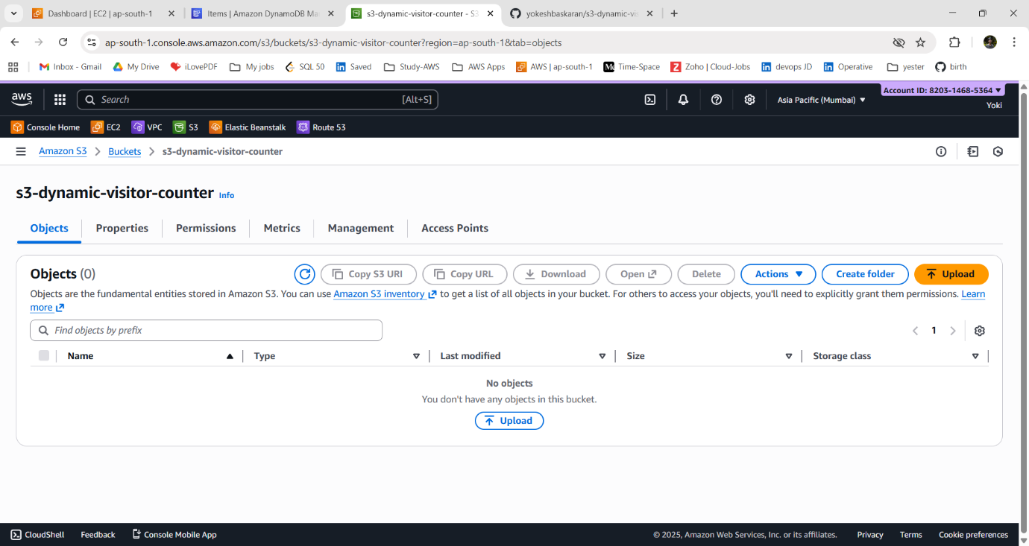

ii) Choose **Upload** to upload the files.

iii) Add all files related to your website (e.g., index.html, error.html, CSS, JS files).

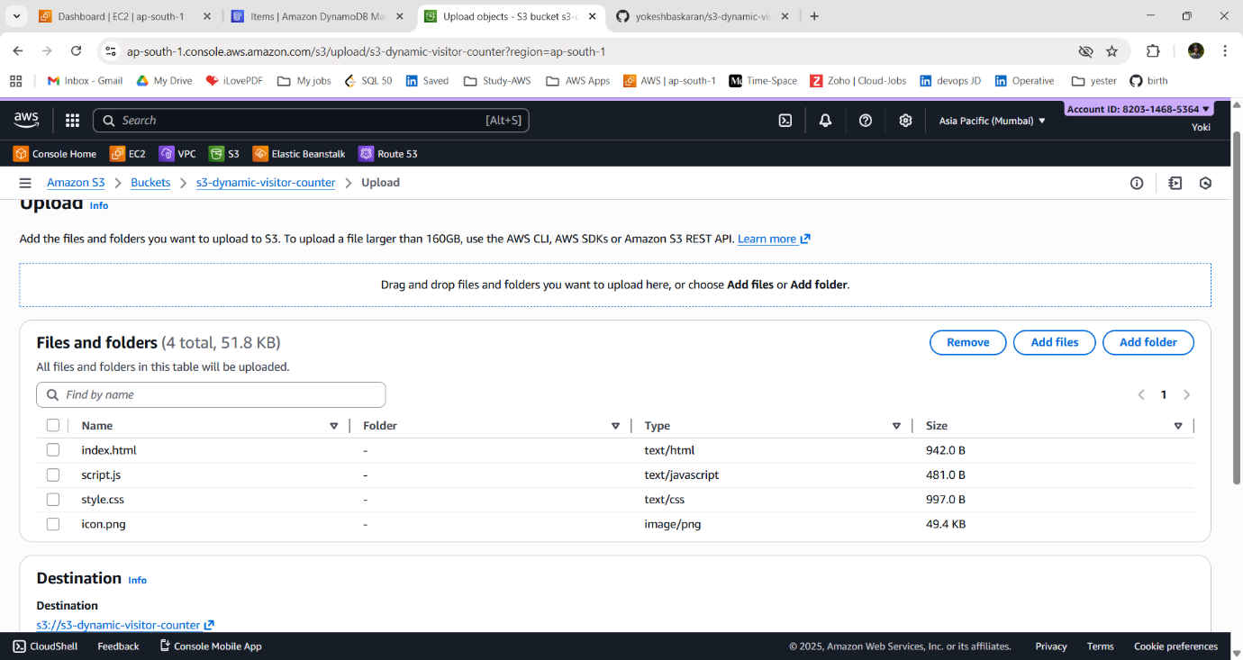

iv) Choose **Upload** again to complete the process.

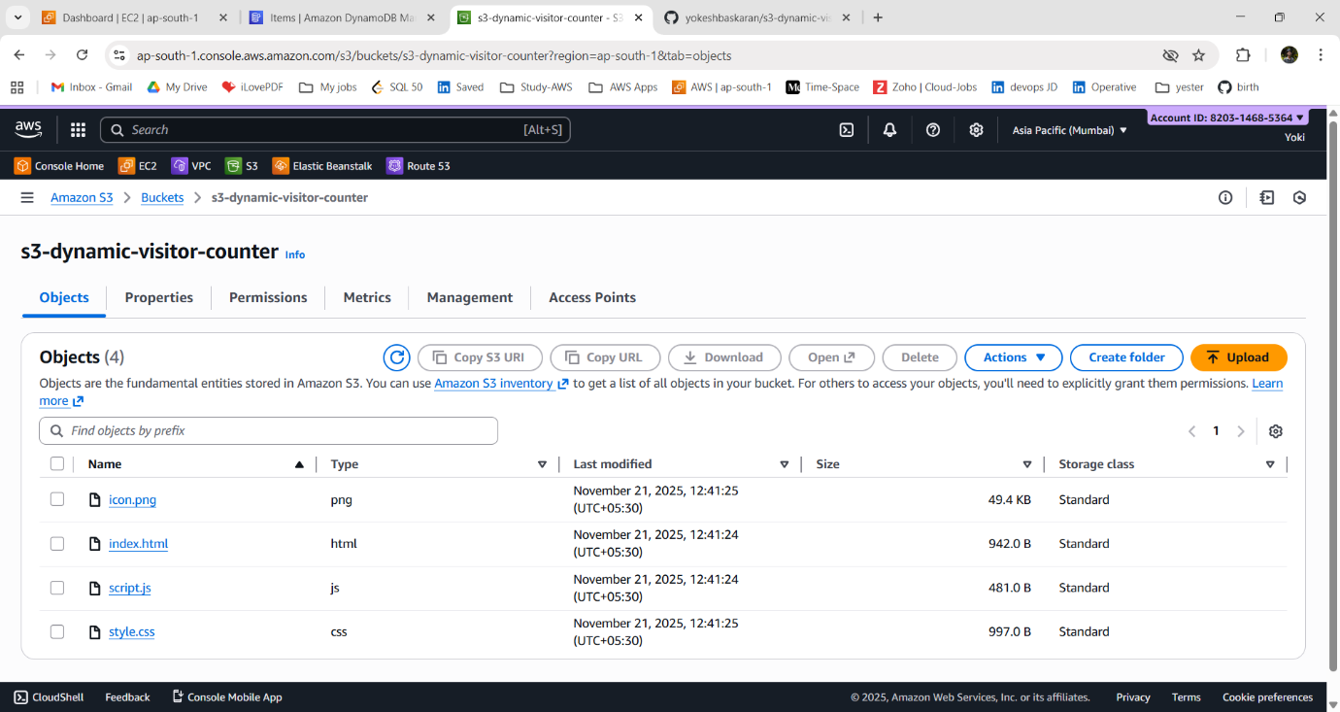

**3. Enable Static Website Hosting:**

i) Go to the **“Properties”** tab of the bucket.

ii) Scroll to **Static website hosting.**

iii) Choose **Edit** and then Select **Enable**.

iv) Choose Host a static website.

v) Set your Index document (e.g., **index.html**).

vi) click **Save changes.**

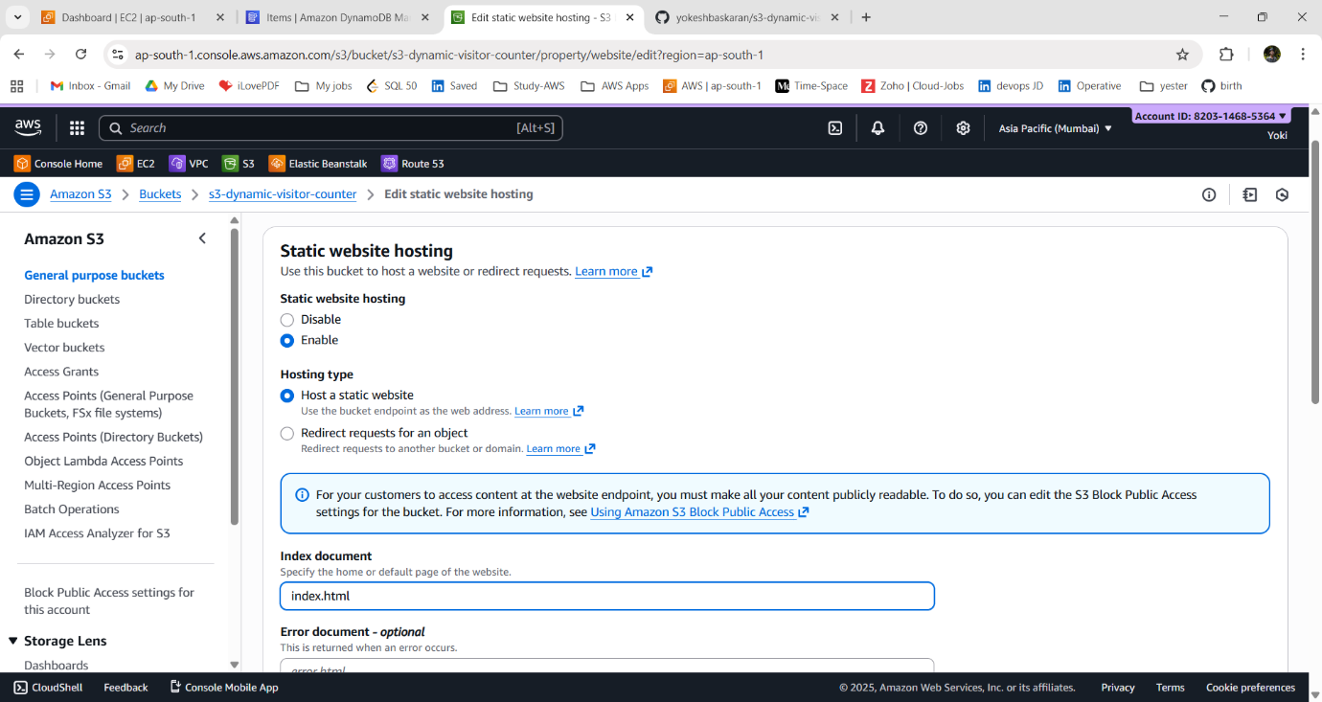

vii) Copy the Website endpoint shown after saving — this is your public website URL.

**URL:** http://s3-dynamic-visitor-counter.s3-website.ap-south-1.amazonaws.com

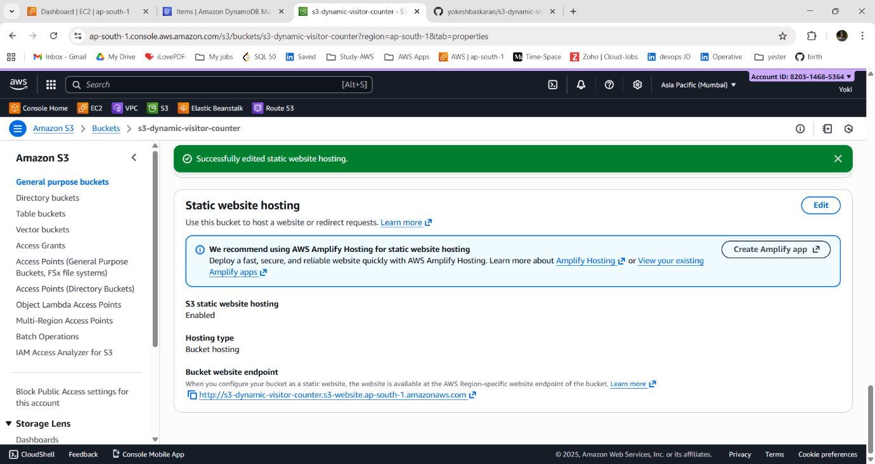

~ If we get 403 Forbidden or access denied. We need to check the bucket settings.

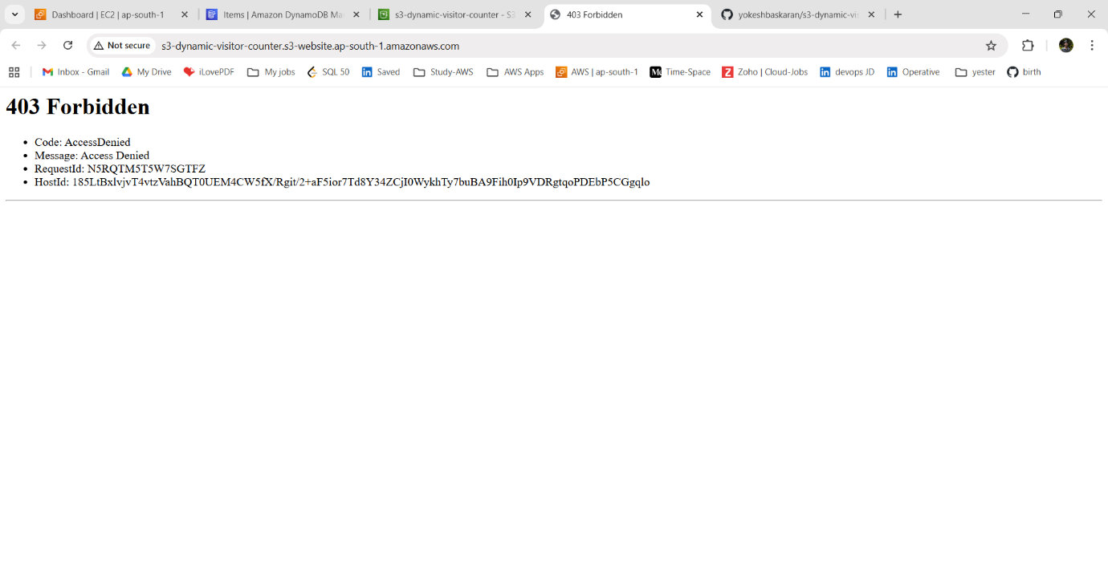

~ we need to **Turn off “Block Public Access”** (bucket settings).

~ Also, give the **Bucket policy.**

**4. Allow Public Access to Website Files and add Bucket Policy:**

i) Go to the **“Permissions”** tab of the bucket.

ii) Scroll to **“Block Public Access”** (bucket settings).

iii) Choose **Edit** and **uncheck** the “Block all Public Access”**.**

iv) type “confirm” and click Save Changes.

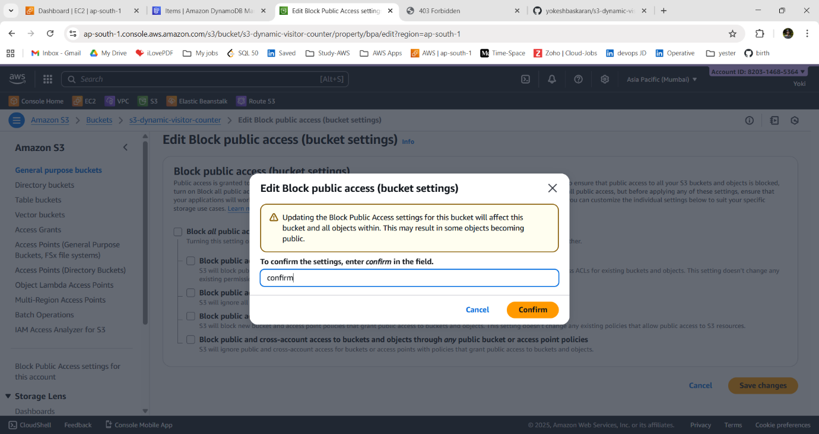

v) In same page of “**Permissions”** tab of the bucket. Scroll to **Bucket policy.**

vi) Choose **Edit** and add a policy that allows public read of all objects in the bucket.

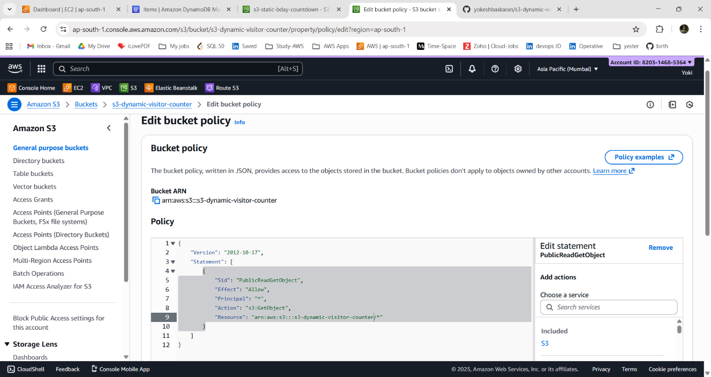

**BUCKET POLICY:**

```

{

"Version": "2012-10-17",

"Statement": [

{

"Sid": "PublicReadGetObject",

"Effect": "Allow",

"Principal": "*",

"Action": "s3:GetObject",

"Resource": "arn:aws:s3:::s3-dynamic-visitor-counter/*"

}

]

}

```

vii) Save the policy.

viii) Verify that Public Access indicators show that the bucket allows public reads.

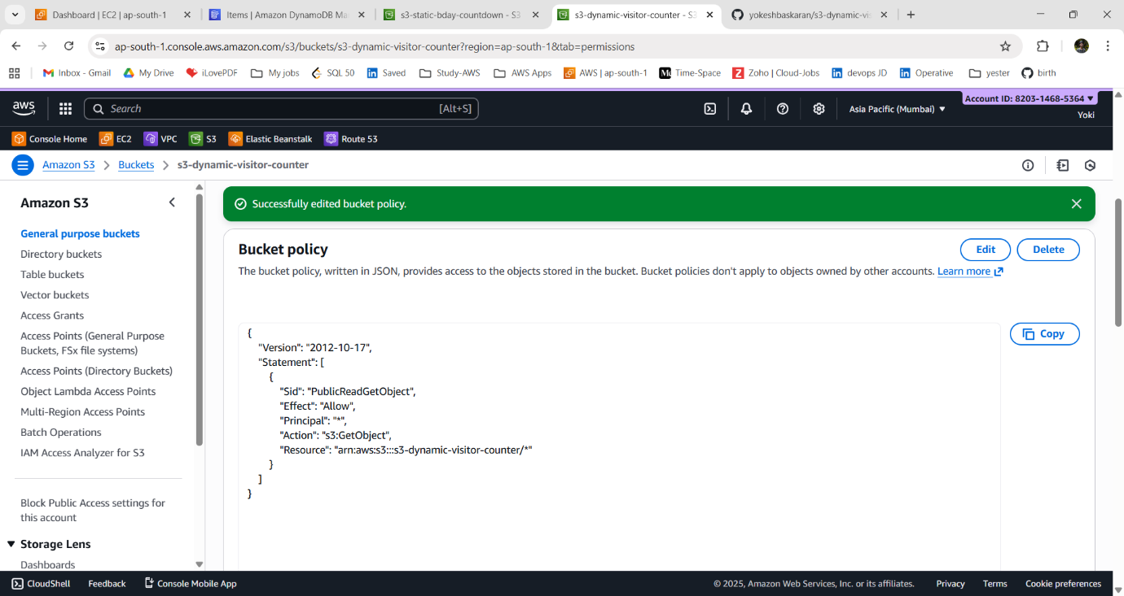

**5. Verify Website Accessibility:**

i) Open the S3 Website endpoint URL in your browser.

ii) Confirm that the site loads and that resources (CSS, JS files) work properly.

iii) If something doesn’t load, check:

- Files are uploaded at the correct paths

- Permissions allow public read

- File names match exactly (case-sensitive)

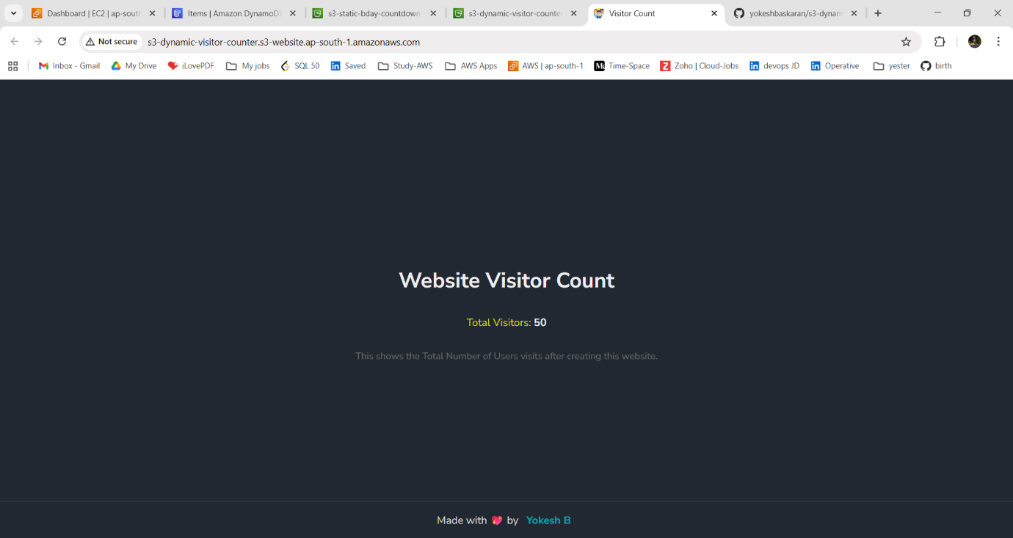

**6. Maintenance & Updates:**

i) To update your site, upload new versions of your files to the S3 bucket.

ii) Overwrite existing objects or delete and re-upload.

iii) Refresh the website to view changes (sometimes a hard refresh is needed: Ctrl+Shift+R).

~ updated code version.

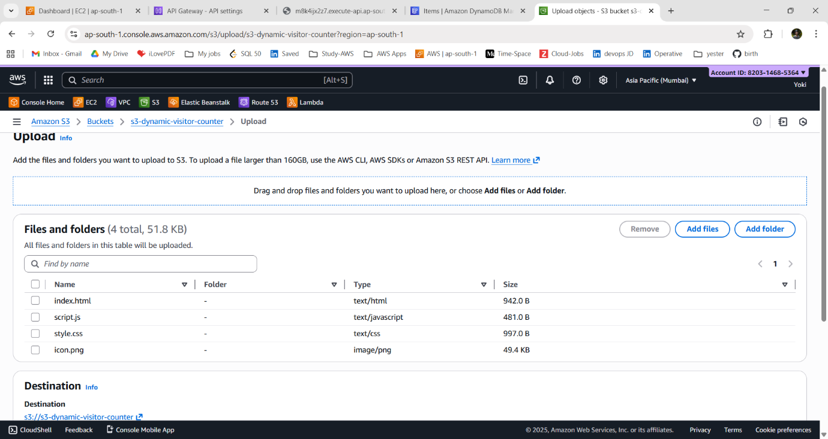

**VISUAL ARCHITECTURE DIAGRAM:**

---

User Browser ← (user visits the website)

↓

S3 Static Hosting ← (serves HTML/JS assets)

↓

API Gateway ← (visitor counter API endpoint)

↓

Lambda Function ← (reads & updates visitor count)

↓

DynamoDB Table ← (atomic counter storage)

---

**CONCLUSION**

The project successfully implemented a **scalable serverless website visitor counter** using AWS Lambda, API Gateway, DynamoDB, and S3. The solution eliminates server management, scales automatically with traffic, and stores visitor data reliably.

By combining these AWS services, the system delivers a lightweight, cost-efficient, and highly available way to track website visits in real time, demonstrating the effectiveness of serverless architecture for modern web applications.